Gantt Chart

Lab

Creating a Gantt chart in **GanttPRO** (or any similar tool) is a great way to visualize tasks and project timelines. Here's a step-by-step guide to create a Gantt chart using GanttPRO:

1. Sign In / Create Account

* Go to [GanttPRO](https://ganttpro.com).
* Sign in using your credentials or create a new account.

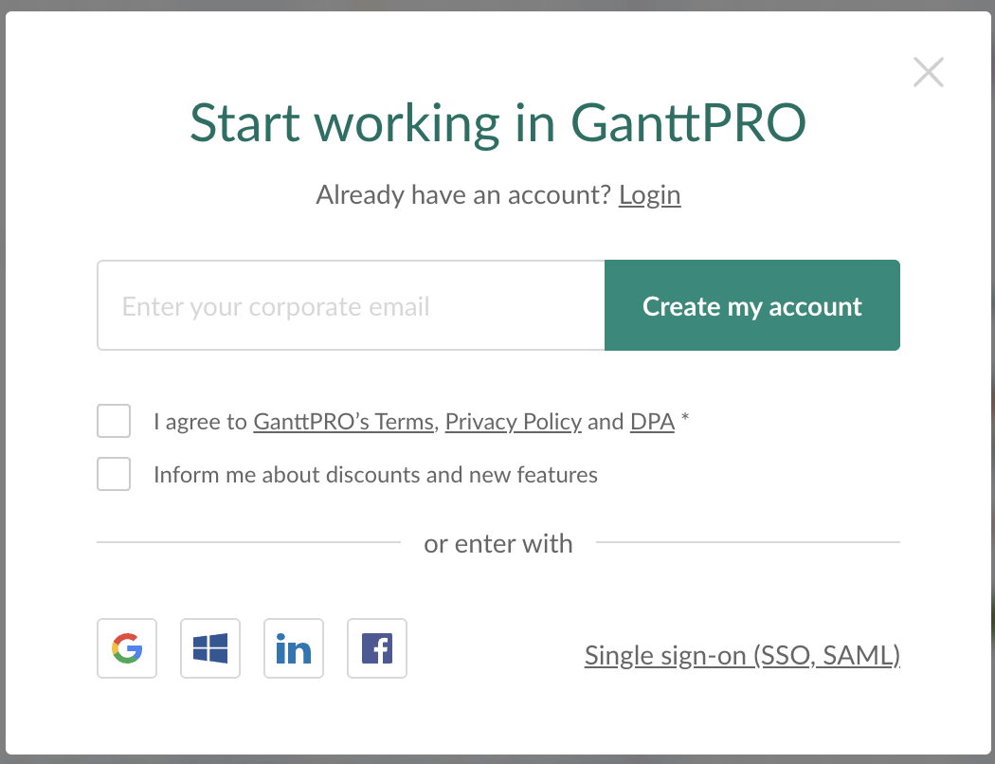

2. Create a New Project

* Once logged in, click “+ Create new project”.



* Choose:
  + Name for the project (e.g., *E-commerce Website*).
  + Template (blank or a predefined one).
  + Start date.
* Click “Create project”.

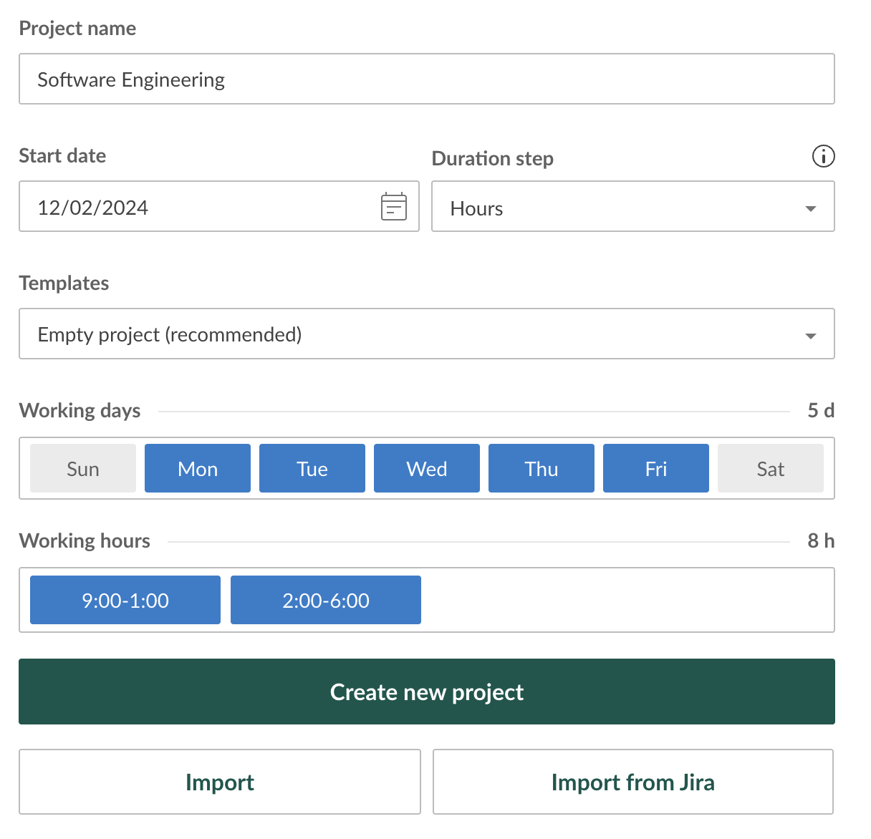

3. Define Project Structure

* Click on Add a task

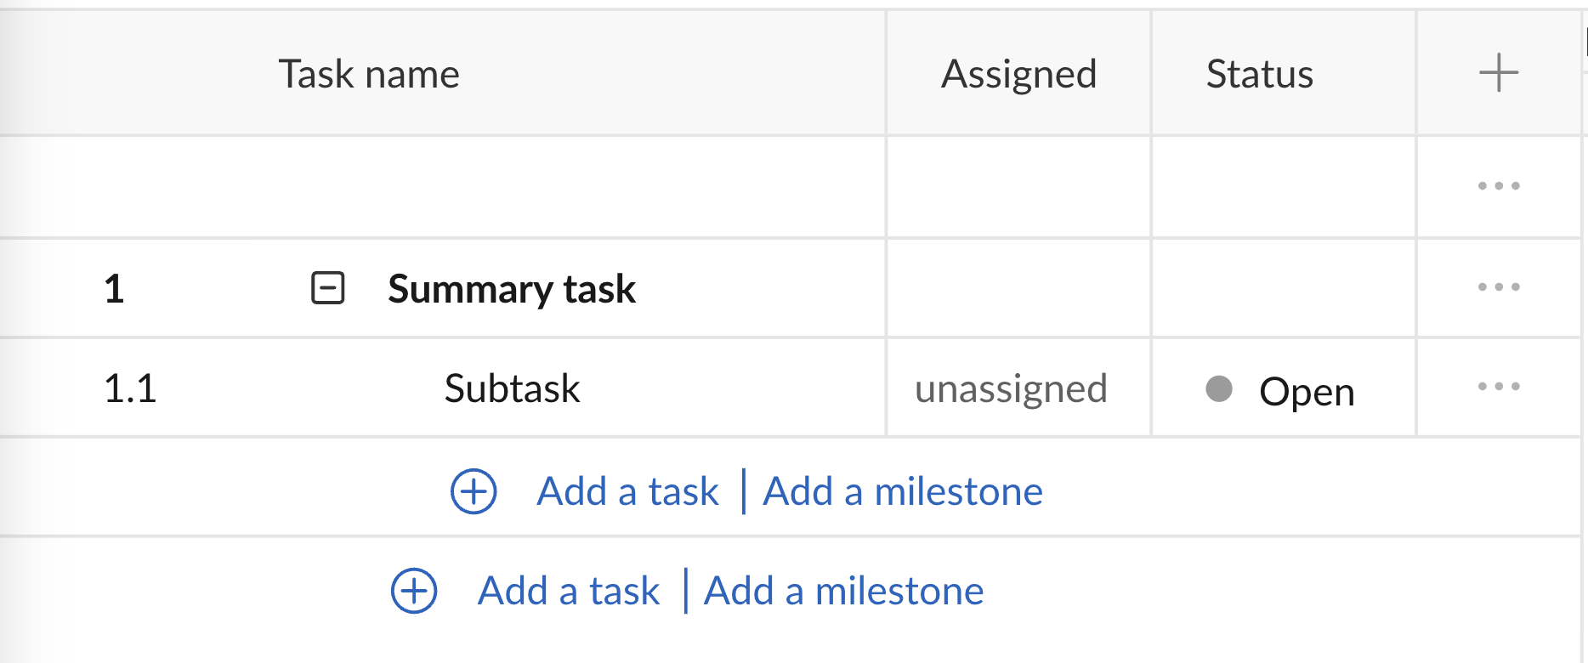

* Add Task and subtask as the requirement
  + - Requirement Analysis
    - Planning
    - First Prototype Development
    - Feedback and Review
    - Second Iteration
    - Final Iteration & Optimization
    - Testing
    - Documentation

4. Set Start and End Dates

* Click on each task’s row.
* Define start and end dates (or drag on the Gantt chart timeline directly).
* You can adjust the duration visually by resizing the task bar.

5. Add Dependencies

* To show task relationships:
  + Hover over the right edge of a task bar → drag the arrow to the start of the next task.
  + This shows that one task must be completed before another begins (Finish-to-Start dependency).

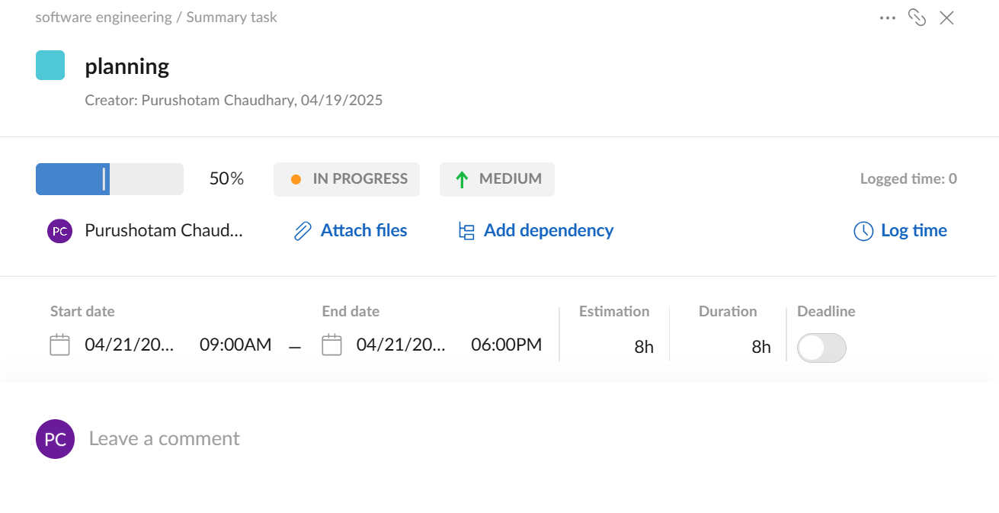

6. Assign Team Members

* Add team members to your project.
* Assign them to specific tasks by clicking on the person icon next to a task.

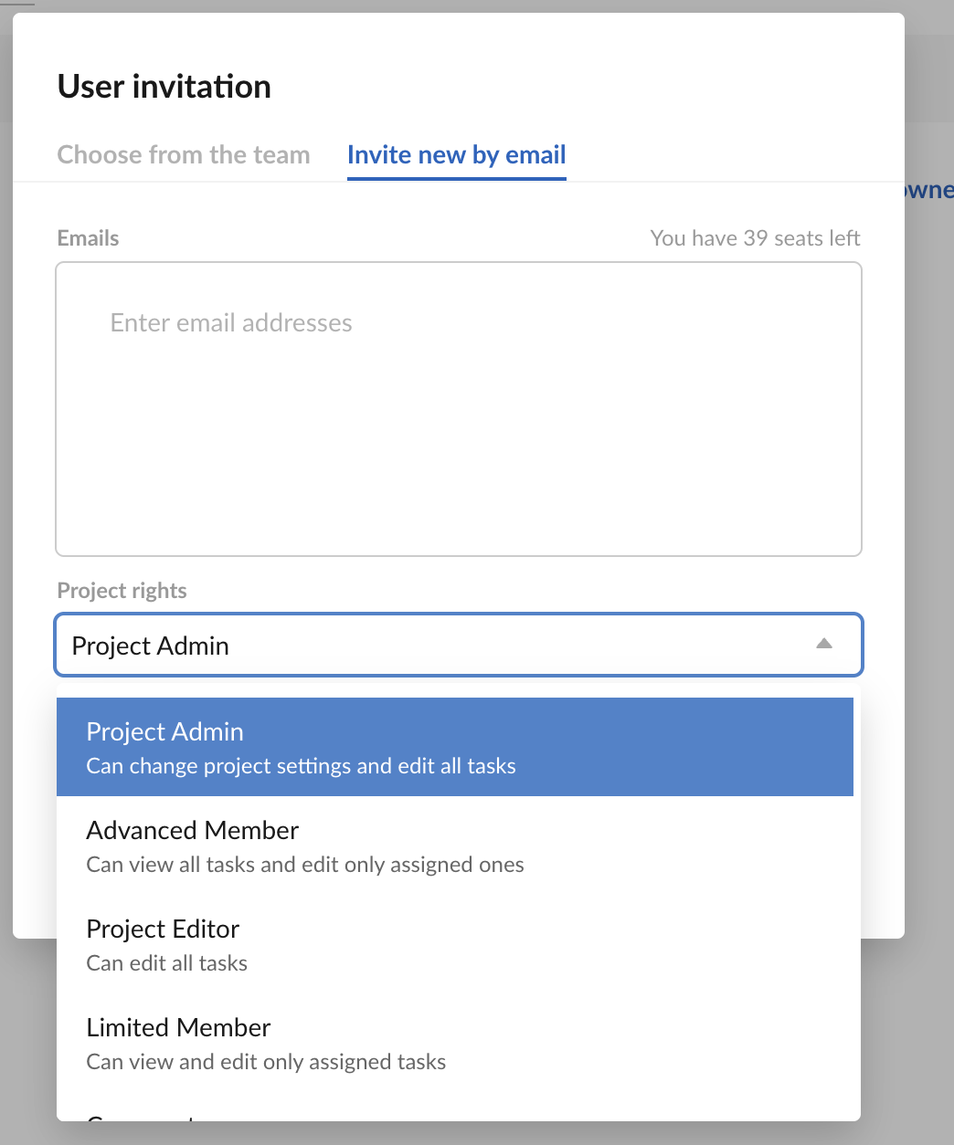

7. Add Milestones

* Click “+ Task” → choose Milestone.
* Set it for key achievements like “Design Approved” or “Product Launch”.

8. Customize View

* Adjust the zoom level (days, weeks, months).
* Use colors to categorize phases or priority levels.



9. Track Progress

* Add progress percentage to each task.
* You can update it manually or let it auto-update based on subtasks.

10. Export or Share

* Click on Export
* Export your chart as PDF, PNG, Excel, etc.
* Or invite collaborators via email for real-time access.

11. Finally our Gantt Chart Look like this:

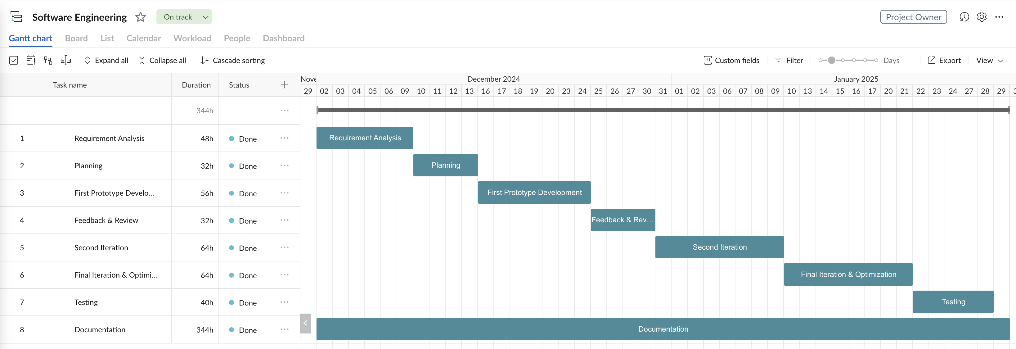

Figure 1 : Gantt Chart of learning management system.